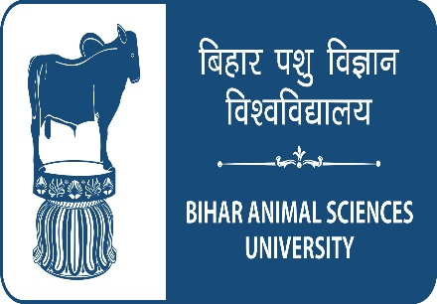 | fcgkj Ik'kq foKku fo'ofo|ky;
BIHAR ANIMAL SCIENCES UNIVERSITY
Patna- 800014
(Established in 2016 under Bihar Animal Science University Act-2016)

APPLICATION FORM
NOTE:- | Please read the General Instructions & Conditions enclosed with application form before filling the application form.

PLEASE INSERT INFORMATION IN BOLD LETTERS |  |  |  | Please Affix self-attested latest photograph
Post Applied for |  | : | ……………………………………………
Dated |  | : | ……………………………………………

1 | Name  (In capital letters) |  | : | First Name |  |  | Middle Name | Surname
2 | Father’s / Husband Name |  | :
3 | Present Address (for correspondence) |  |  |  | :
4 | Permanent Home Address |  |  |  | :
5 | Telephone / Mobile No. |  |  |  | :
6 | Email |  |  |  | :
7 | Fax No. |  |  |  | :
8 | Are you a bonafide resident of Bihar (If Yes, give full address and attach proof) |  |  |  | :
9 | Date of Birth in figures  (According to Matriculation Certificate) |  |  |  | :
10 | Date of Birth in words  (According to Matriculation Certificate) |  |  |  | :
11 | Age as on last date of submission of application |  |  |  | :
12 | Nationality |  |  |  | :
13 | a. | Mother Tongue |  |  | :
 | b. | Other language (s) which the applicant can speak, read and write fluently |  |  | :
14 | Whether belong to SC / ST/ EBC / BC/EWS/WBC Category (Candidates of original resident of Bihar, in support please enclose a certificate from authorized issuing officers) |  |  |  | :
15 | Examination Passed (Please enclose copies of certificate / degree and mark sheet / transcript etc. of each of the examinations)

Examination* |  | Name of the degree / diploma | Name of the University or other examination body | Percentage of marks / OGPA obtained | Division | Year of passing | Subject (s) (Major)
i. | Matriculation
ii. | Higher Secondary / Intermediate / Pre-University
iii. | Bachelor’s Degree
iv. | Master’s Degree
v. | Doctor’s Degree

*Only completed and awarded qualifications should be mentioned. Incomplete or result awaited qualifications should not be mentioned or clearly indicated.

16 | Experience: Teaching, Research, Extension, Field work or any other (Please describe each of the experience separately and in detail with its duration and dates):  ………………………………………………………………………………………………………………………………..  ……………………………………………………………………………………………………………………………………………………………………………………………………………………………………………………………….
17 | Publications, if any, with their titles please list your Publications in bibliographic form, they should be classified into Scientific papers, Extension publications (Booklets / Bulletins), Books (Authored / Edited), Manuals, Book Chapters, Popular articles etc.:
18 | Additional remarks, if any  ………………………………………………………………………………………………………………………………..  ……………………………………………………………………………………………………………………………………………………………………………………………………………………………………………………………….

NOTE: | All the statement should be supported by proof enclosure wherever necessary. If the space is insufficient additional sheet may be used where ever required.
DECLARATION
I ……………………………Son/Daughter of ……………………. hereby declare that all the statements and entries made in this application are true, complete and correct to the best of my knowledge and belief. In the event of any information being found false or incorrect or ineligibility being detected before or even after the selection my candidature/ appointment may stand cancelled.

Signature of the Applicant

Name (in block letters)

Date:- (Application not signed by the candidate is liable to be rejected.)

